Day 2 - Containers - Microservice Architecture

Task : Install docker on EC2 and explore the docker commands (docker images, containers, volumes, network)

1. Install docker on EC2

Followed this doc and installed docker in EC2 instance

<https://docs.docker.com/engine/install/ubuntu/>

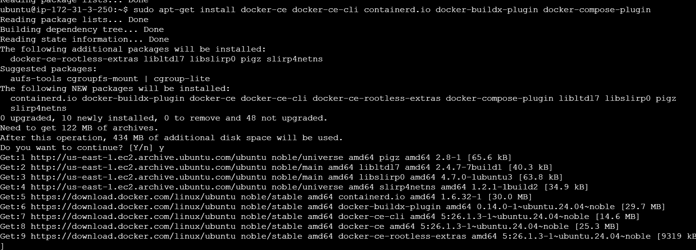



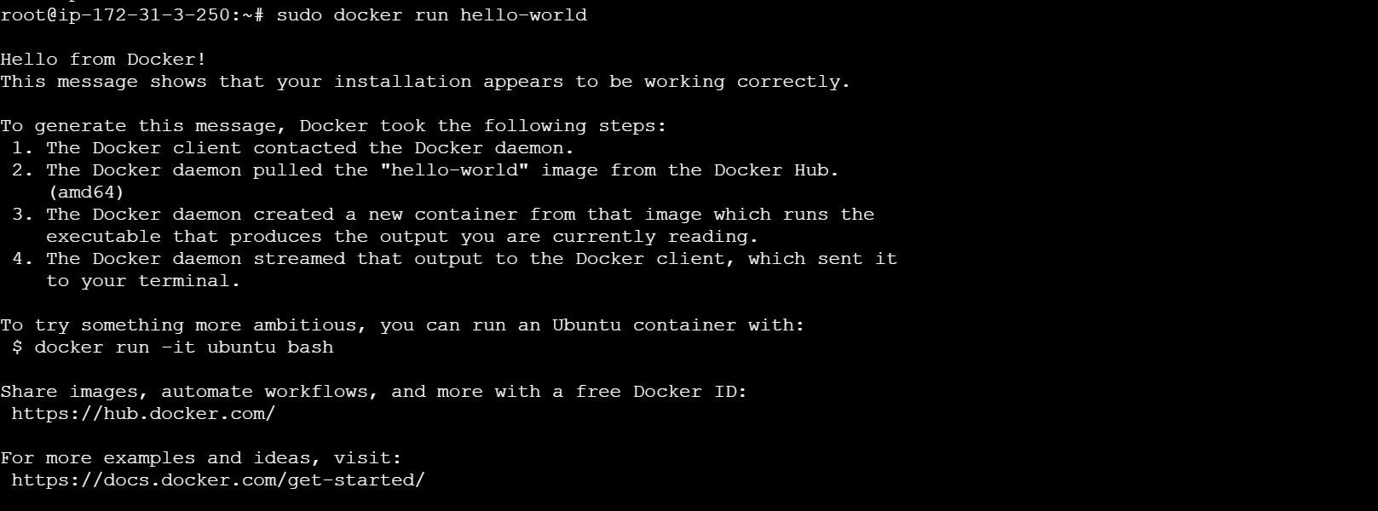

Docker Commands :

1. Version : docker –version

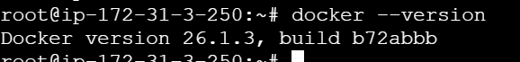

1. Docker pull – to download an image

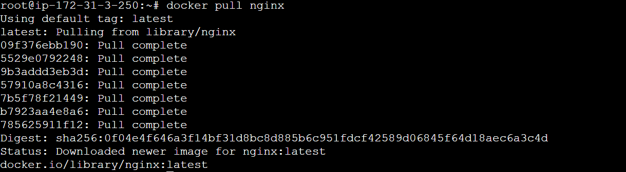

1. Docker images – to list images

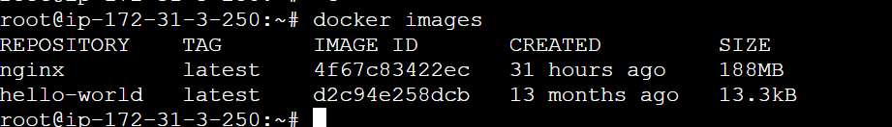

1. To remove image - docker rmi my-nginx

First all the container using that image should be stopped and deleted

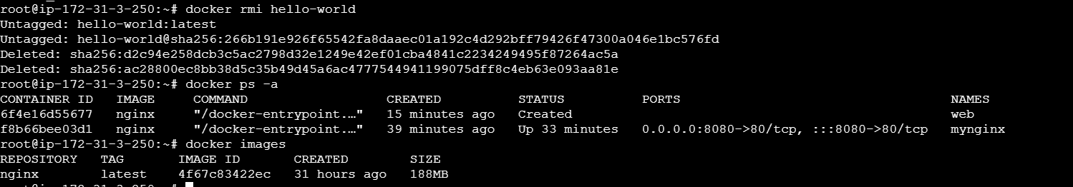

1. Docker run



1. To see all running containers : docker ps



1. To stop the container : docker stop containername

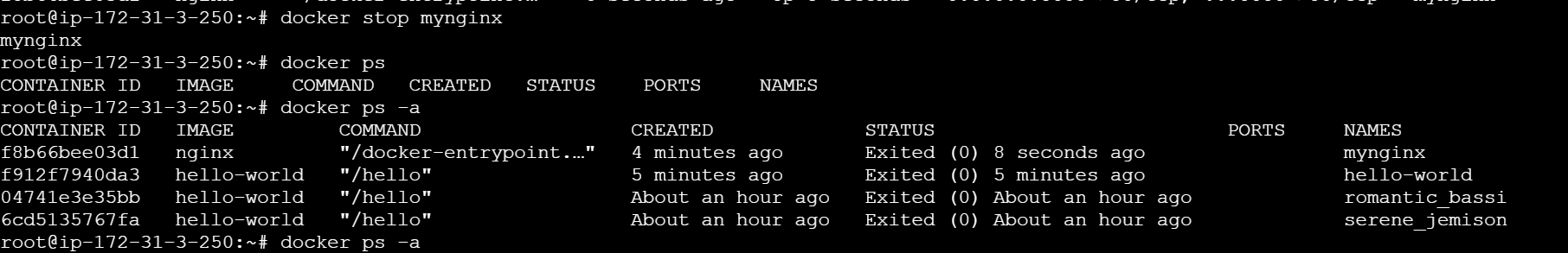

1. To start : docker start container name

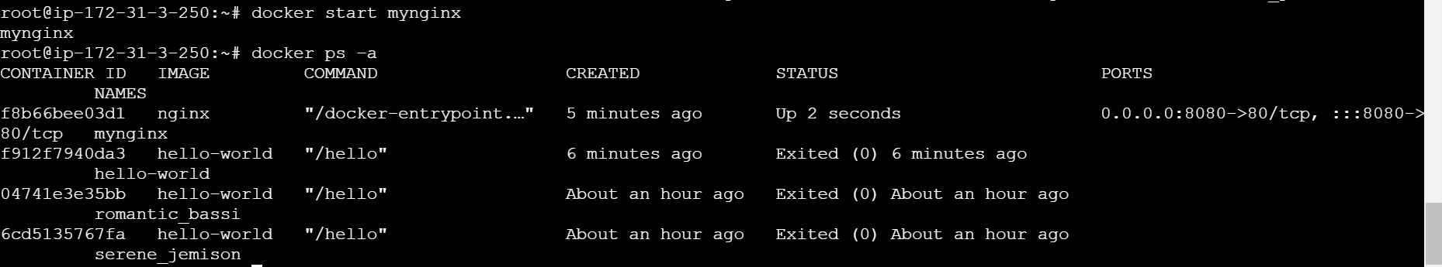

1. To list all container even stopped one



1. To remove container

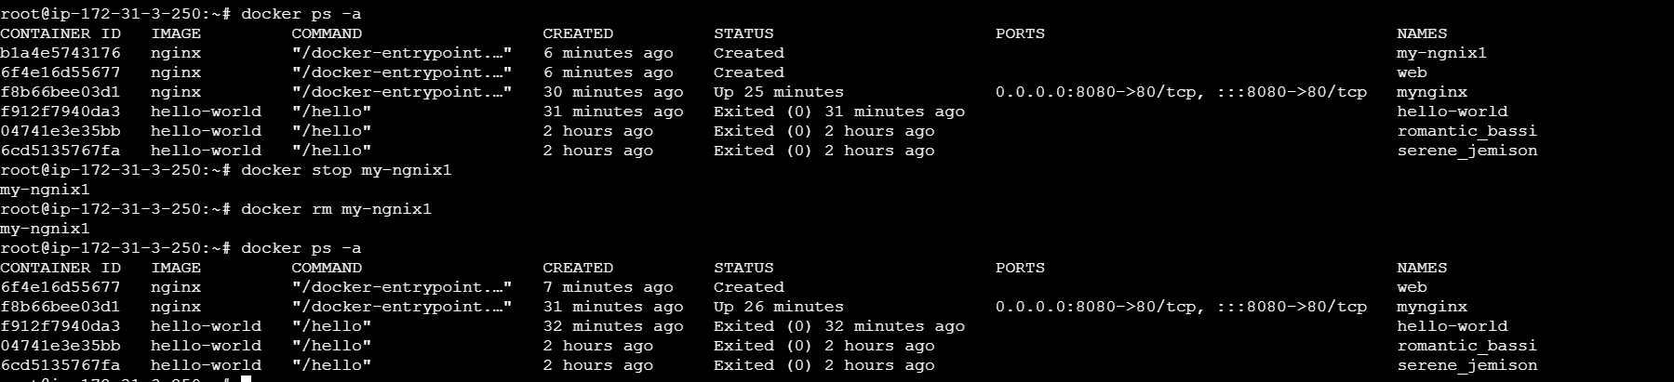

1. Create volume and list

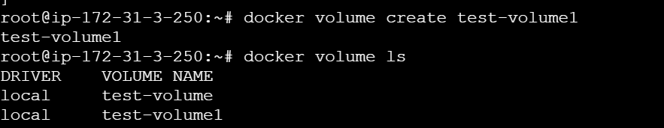

1. Get information about the volume

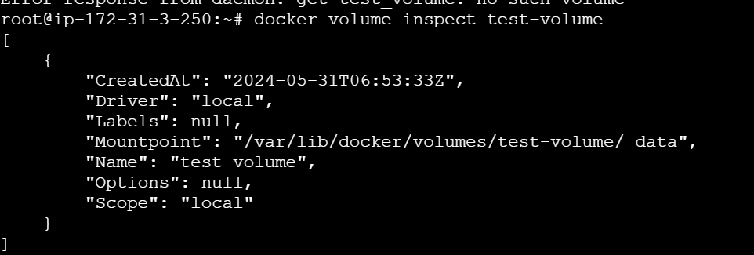

1. Remove volume

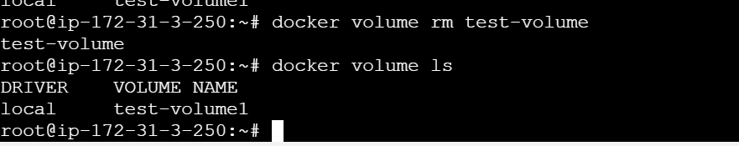

1. Create a network



1. List the network –

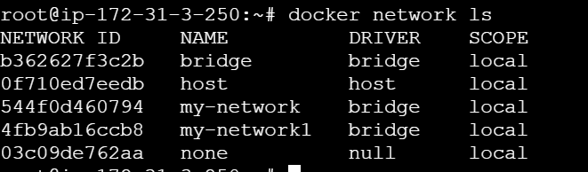

1. Inspect the network ;

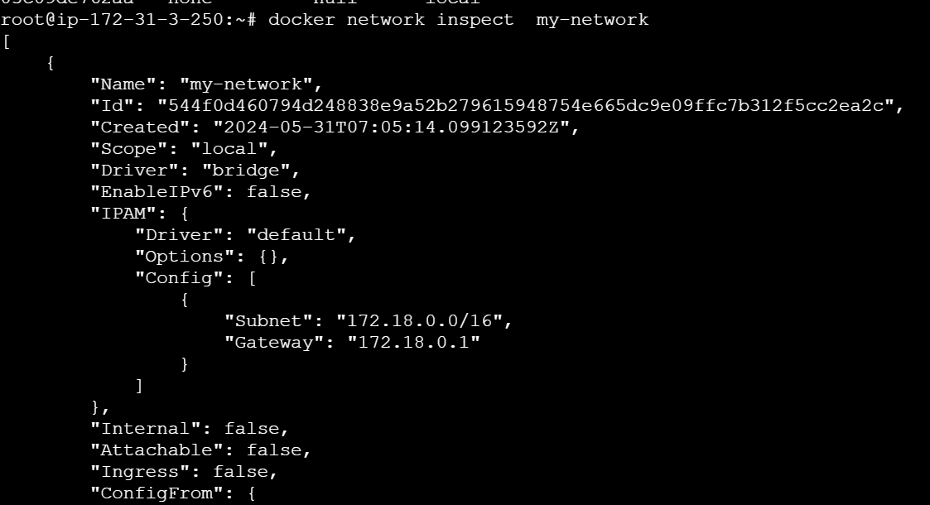

1. Run the container and connect with the network –



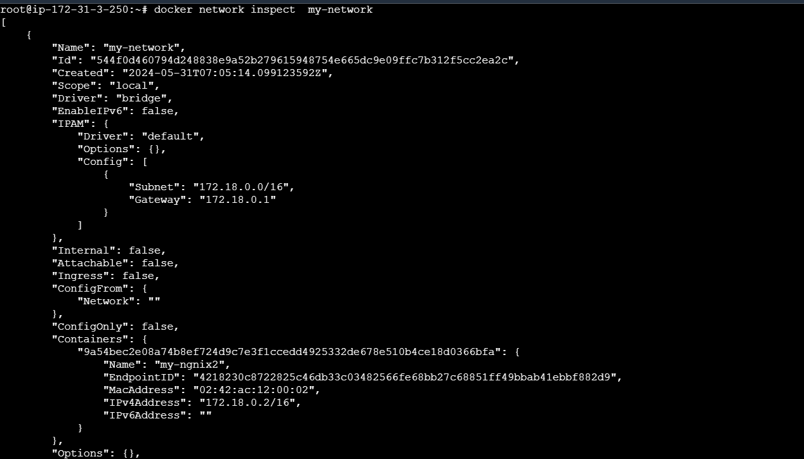

1. Remove network
2. First stop and remove the container

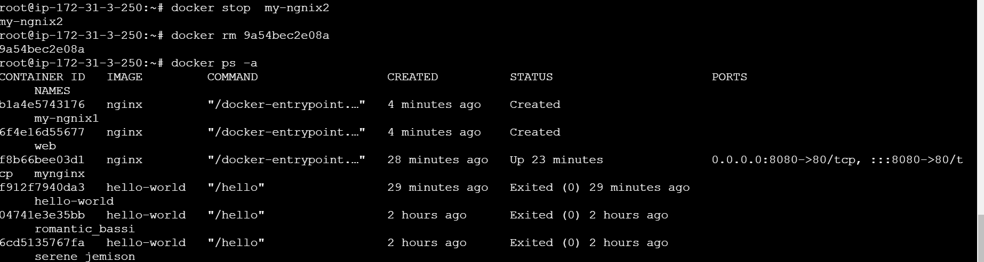

1. Now remove the network

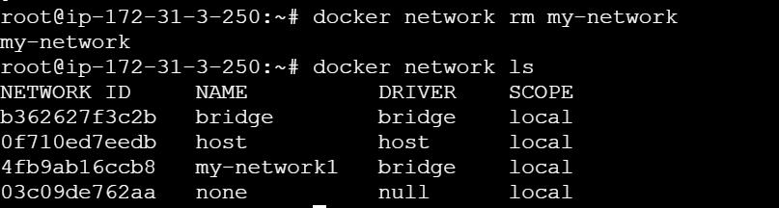

1. Connect network to existing container



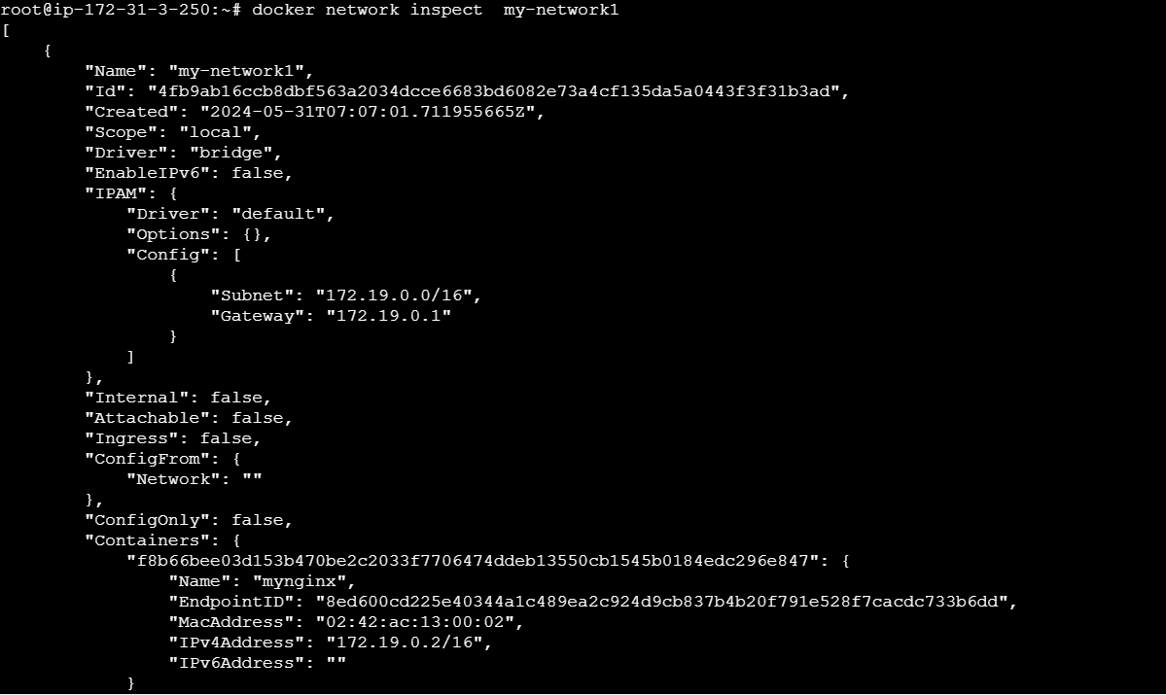

1. Disconnect

